**Synchrony**

Final Report Write-up

Jacob Alspaw

Owen Helmstetter

Alex Hemm

Ted Timbrell

Bobby Wagner

A synchronized streaming service aiming to make the music listening experience social again by enabling users to choose songs to listen to and talk about together

**Version 1.0**

December 14, 2018

**Table of Contents**

**1. Introduction** **2**

1.1 Purpose 2

1.2 Vision 3

**2. Features** **3**

2.1 Lobbies 3

2.2 Streaming 4

2.3 Real Time Communications 4

**3. GUI Description** **5**

3.1 Home Page 5

3.2 Joining / Creating Lobby 5

3.3 Typical Lobby 5

3.4 Lobby Flexibility 6

3.5 Settings 6

3.6 Figures 7

**4. Languages / Tools** **12**

4.1 Frameworks 12

4.2 Tools and APIs 12

**5. Architecture / Design** **12**

5.1 Application Architecture 12

5.2 Client-Side Architecture 13

5.3 Key Components 14

5.4 Database Design 15

**6. Testing / Documentation** **16**

6.1 Testing 16

6.2 Test Cases 16

6.3 Documentation 17

**7. Use Cases** **19**

**8. Project Status** **20**

8.1 Accomplishments 20

8.2 Omissions 21

8.3 Lessons Learned 21

**9. Conclusion** **22**

**10. Individual Contributions** **22**

10.1 Jacob Alspaw 22

10.2 Owen Helmstetter 25

10.3 Alex Hemm 26

10.4 Ted Timbrell 28

10.5 Bobby Wagner 30

## 

## **1. Introduction**

### **1.1 Purpose**

The music industry and the ways in which we listen to music are rapidly evolving. The development and introduction of music-streaming services has given music listeners a new form of easy access to any and all types of music. Listeners use these streaming services in tandem with their devices to create the music listening experience many have come to know and love. Even though the devised system for listening to music often proves unproblematic, it is nowhere near perfect.

The current ways in which we listen to music are flawed. Standalone speakers often subject others to forced listening conditions. They carry a stigma in public areas where peace and quiet are expected thereby limiting their use. Audio from mobile phone speakers is poor or mediocre at the very least compared to most inexpensive headphone sets. High quality and cheap headphones have reduced the need for cumbersome standalone speakers in people’s everyday lives, however, headphones create a barrier between listeners and degrades the shared listening experience that standalone speakers promote. So how can we ensure that music remains a shared experience amongst many enthusiasts?

Improving upon the current music-streaming services is just one way in which we can ensure a shared experience amongst listeners. Current methods for contributing to the music listening experience lack a key feature. It is apparent that industry-leading music-streaming providers, like Spotify, have simply overlooked the needs for synchronously playing music amongst multiple users. These large services only allow a stream to be sent to and controlled by one person at a time. When the services limit stream access to a single person, they thereby limit the overall user experience. If stream access could somehow be given to multiple users, the user experience would dramatically improve with means for group listening and collaborative control.

### **1.2 Vision**

The next evolution in how we listen to music is Synchrony, a synchronized streaming service provided by a dedicated team aiming to enhance the music listening experience of users through shared playlist collaboration and discovery. Synchrony acts a wrapper to mainstream music providers, captures their streams, and then relays the stream to Synchrony users. Our service allows users to collaboratively listen to music in groups (even when wearing headphones), and enables control over the current song queue for each person in the group . Synchrony allows users to keep using their individual devices and streaming services while effortlessly and seamlessly sharing their experience with friends.

Synchrony’s functionality is found in its many lobbies where users engage in interactive listening experiences. Users will be able to create and join lobbies, invite their friends, search for songs to add to the lobby queue, control soundtracks, and use real time communications. Because these lobbies offer shared synchronous playback, Synchrony acts as a fantastic solution to many problematic ways in which we listen to music today.

There are many ways in which Synchrony can be used. Playing music in public through speakers is considered a social taboo. Our platform would allow users to avoid disturbing others on public transport, or at serene beaches or parks where a cumbersome standalone speaker is either unavailable or inappropriate. Synchrony also enables users multiple controls over a stream. Is someone connected to your bluetooth speaker and playing their terrible music? Connect both phones to a Synchrony lobby and you can skip their music and add your own song suggestions to the queue!

## **2. Features**

### **2.1 Lobbies**

*Overview*

The primary feature for our application is listener lobbies. These lobbies are the main interface for users to have an interactive listening experience. Synchrony allows patrons to join other lobbies or create their own lobbies. Listener lobbies provide a graphical user interface that lets users interact with the audio streaming service and display other components such as the song metadata and chat room.

*Creating a lobby*

If a guest clicks on a create lobby button, then the create lobby page dynamically loads. Future versions might include lobby types, but the current version autocreates a Spotify type lobby. A unique identification code is generated and the host can share this code their friends to allow them to join the lobby. The host has to share this code by either showing other people in person or sending it through an alternative communication platform.

*Joining lobbies*

If a guest clicks on a join lobby button, then the join lobby page dynamically loads. From this page, guests can enter the unique identification code associated with a lobby. If the code is correct, then the guest is granted access into the lobby. If the code is incorrect, then the guest is shown a validation error and will be asked to enter a different access code. Guests can receive this code from either the host of the lobby or any other user that is currently in the lobby.

*Leaving lobbies*

Hosts and guests are both able to leave an active lobby. Once the user has successfully left the lobby, they will have the option to either join a lobby or create a new lobby.

*Setting guest alias*

When a user joins a lobby, they can change their display/username. This is persistent across lobbies.

### **2.2 Streaming**

*Overview*

The streaming service feature is responsible for delivering synchronized audio to each user in a lobby. The service maintains the current time position on the audio track, and displays the song metadata obtained by the web API.

*Spotify API*

The Spotify API serve as the source of audio for each listener lobby. Synchrony uses Spotify’s Web Playback SDK to serve songs on the client side and their standard Web API to play requested songs from the backend. Synchrony uses the web API to maintain the current position of the audio track and send this data to all listeners in the lobby.

### **2.3 Real Time Communications**

The final main feature Synchrony implements is real time communications between listeners in the lobby. The real time communications that our development team implemented is a chat room that allows users to write messages to a discussion board that is displayed to everyone in the lobby. The chat system lists the name of the user who posted it. Users can include messages that contain reactions to the current audio file or request another track or style of music to be played. When a new song begins to play, metadata about the song is listed in the chat room.

## **3. GUI Description**

Below you will find examples of Synchrony’s user interface. Synchrony’s pages are home, join, create, lobby, and settings.

### **3.1 Home Page**

The page guests see when the base URL is visited. The top banner is part of website’s layout and will remain consistent regardless of what page a guest visits. This banner shows the service name and icon, a join lobby button, a start lobby button, and a settings button. The remaining portion of the layout page describes our service using our current mission statement. Guests will be greeted with additional options to join or create a lobby to expedite and ease the process.

### **3.2 Joining / Creating Lobby**

Guests can choose to either join a lobby or create a new lobby by pressing one of two action buttons. If guests choose to join a lobby, they are navigated to a page with a form that asks users to enter the lobby code. The code is a GUID that users must share with others who wish to join the lobby. If the user wants to create a new lobby, then they will be navigated to a page with a form that asks them to enter the name of the lobby. Once either form is complete, the user will be navigated to a new page and enter the lobby.

### **3.3 Typical Lobby**

Once a lobby has been entered, you will notice four main components. The left side bar contains basic information about the lobby: the members and individual member information, the lobby type, and the unique lobby access code. The add guest button will allow lobby participants to invite new members by copying the unique lobby access code to their clipboard. Lobby participants are required to distribute the code to potential new guests.

The middle of the page shows the chat log and allows lobby participants to send messages. The chat log includes many message type. User messages are sent between users. System messages allow for users to know when others have joined and left a lobby. Music metadata messages will display when music has been queued or played by a user and who is responsible for doing the action.

The right sidebar is used to search for music and add songs to the current queue. The search results are dependent on lobby type and search text. If no search text is entered, then the section will show results from a query that gathers the top fifty most popular songs worldwide.

The top banner will show the currently synchronized song along with a set of controls to play, pause, and skip tracks. Their will also be a Spotify logo. If Spotify authentication is required by the user, then music metadata and playlist controls will be hidden from the user. The user will regain access to these components once authenticated. The Spotify logo will act as a link for users to authenticate.

### **3.4 Lobby Flexibility**

As it is currently built, the website is extremely flexible for users with different size displays. Lobbies can be easily navigated even when viewed from very small screen sizes. The lobby layout is reactive to screen size and will shrink, grow, and even rearrange when necessary to accommodate the current viewing width and height. Depending on width of the screen, components will shift positions to give users the very best experience when using the Synchrony application.

### **3.5 Settings**

If a guest clicks on the settings button, then the settings page will dynamically load. From this page, guests will be presented with a set of configuration options for their Synchrony experience. The options include choosing a website theme, setting up their in-lobby name, and selecting filtering options for their chat logs. The theme options apply a different color scheme to the website. The chat log filters can reduce clutter in the chat room component of a lobby.

### **3.6 Figures**

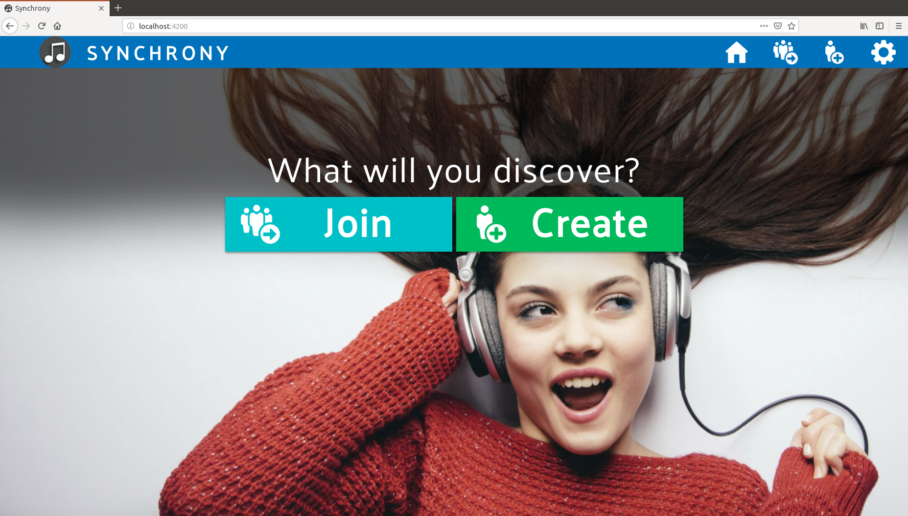

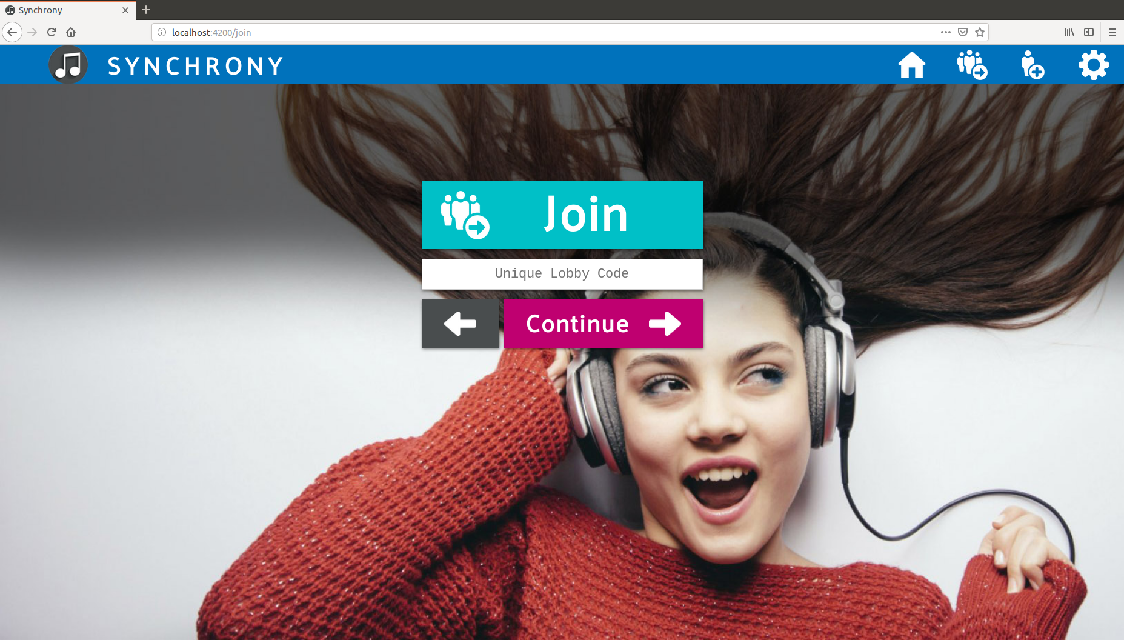

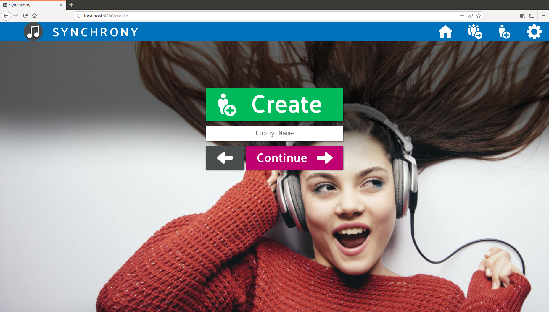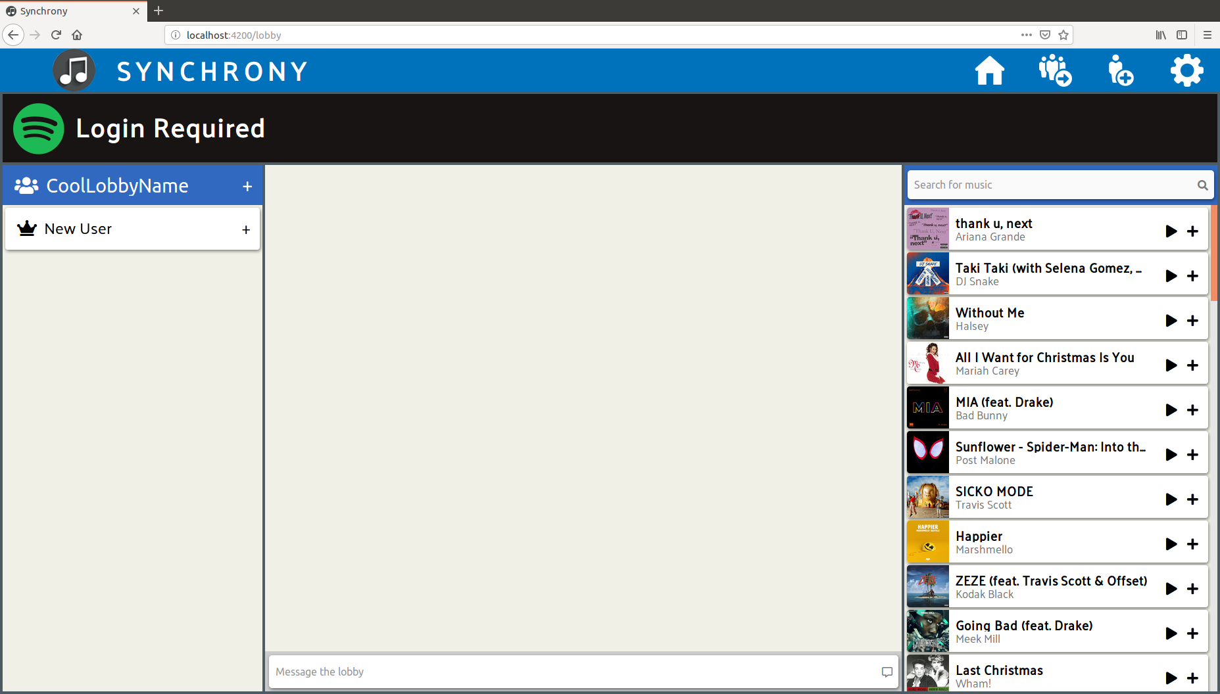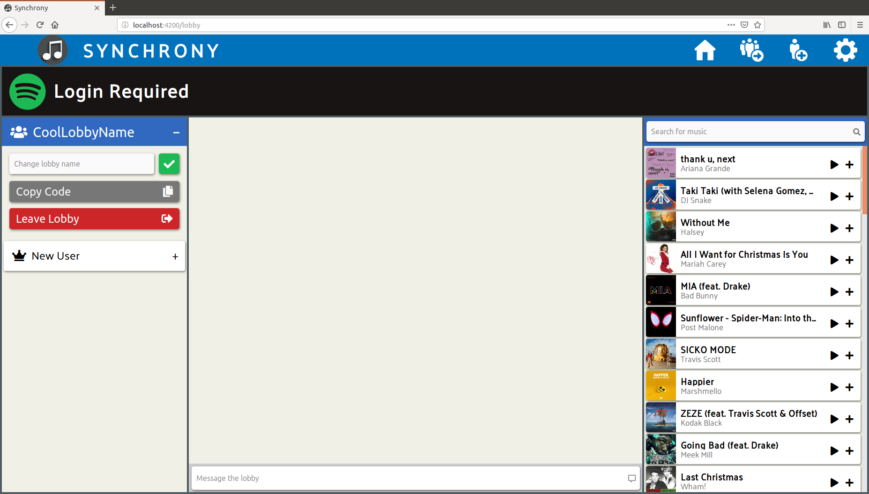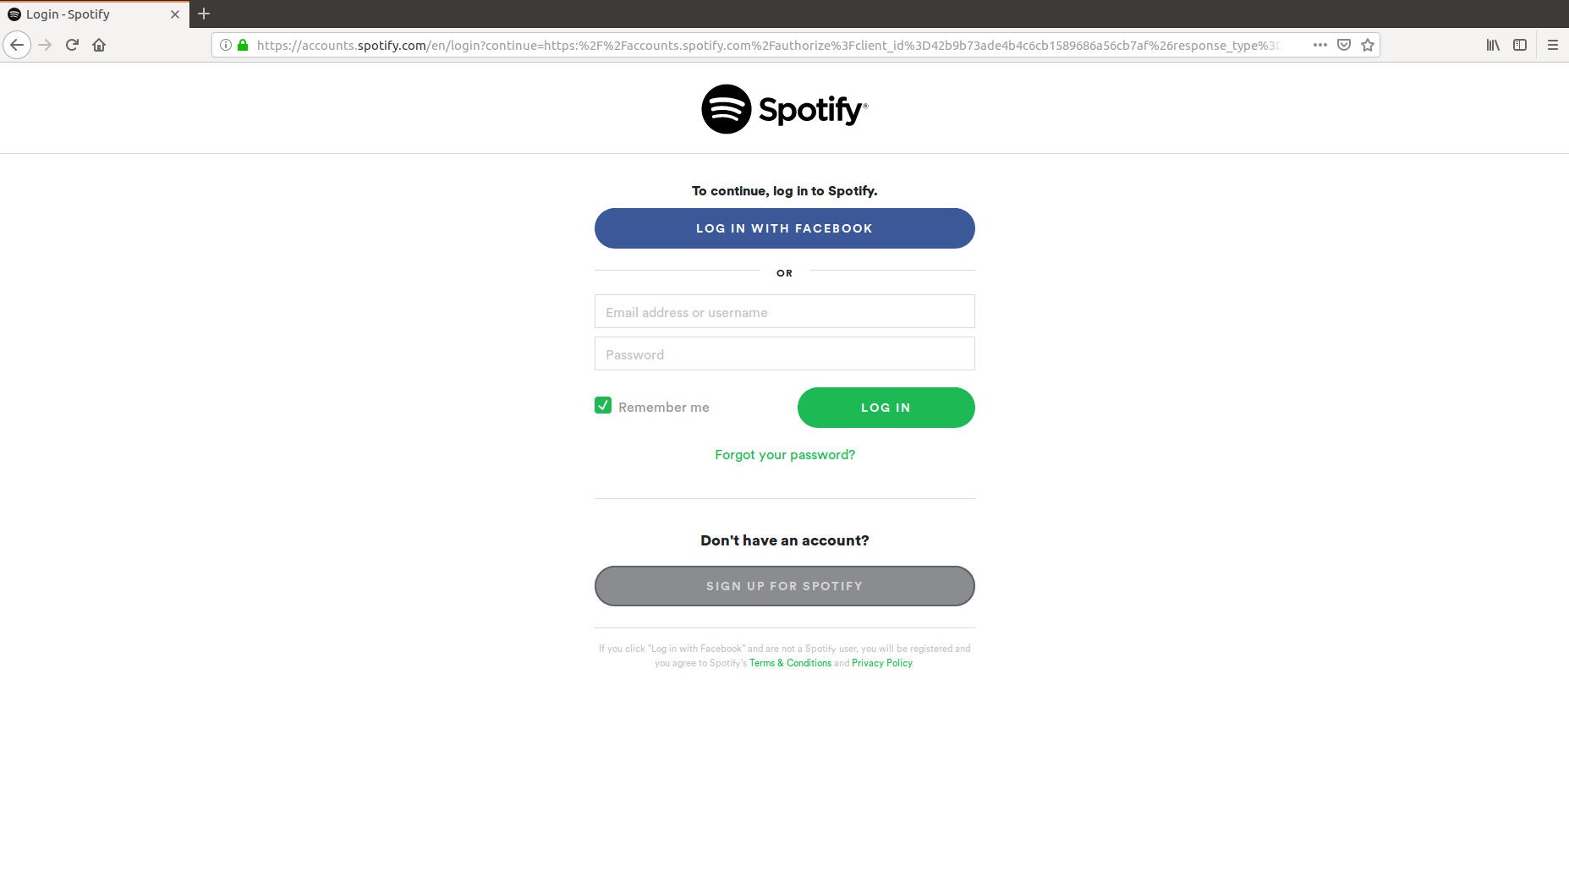

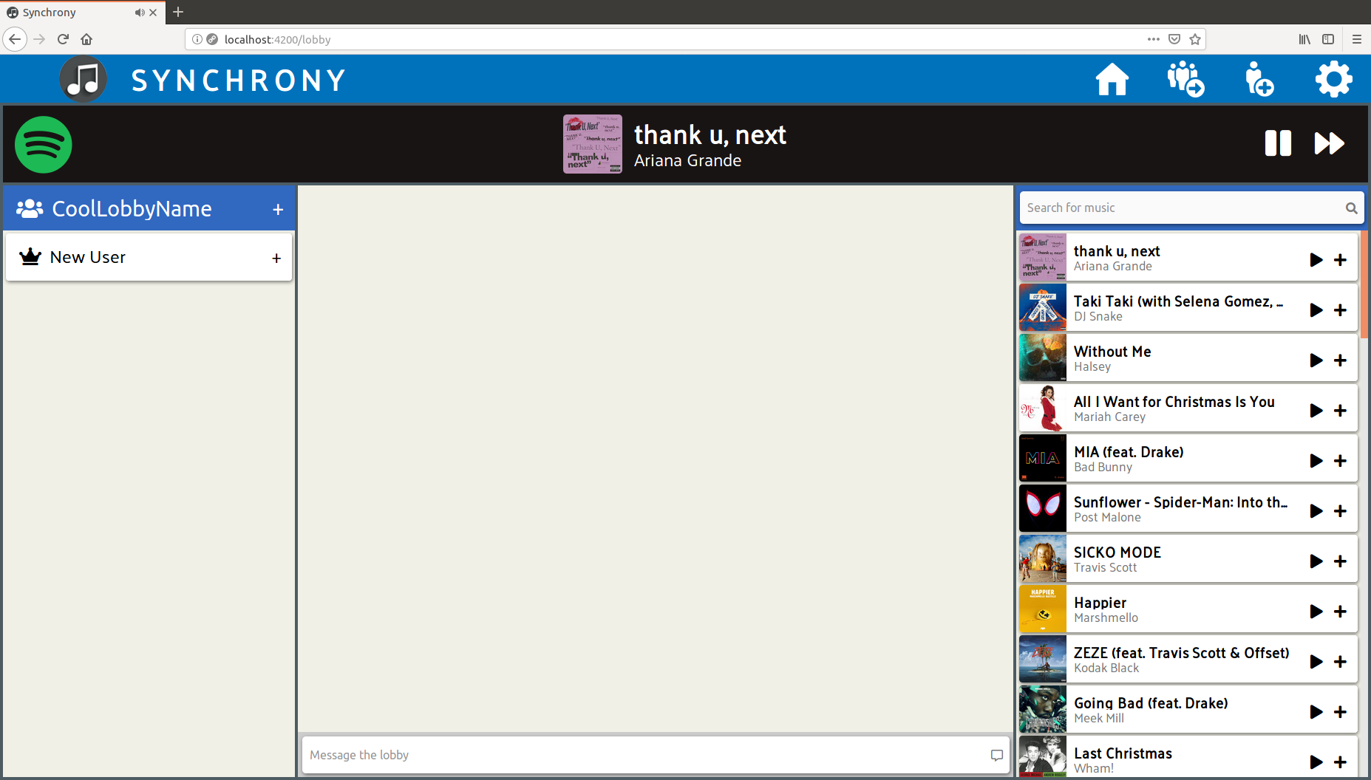

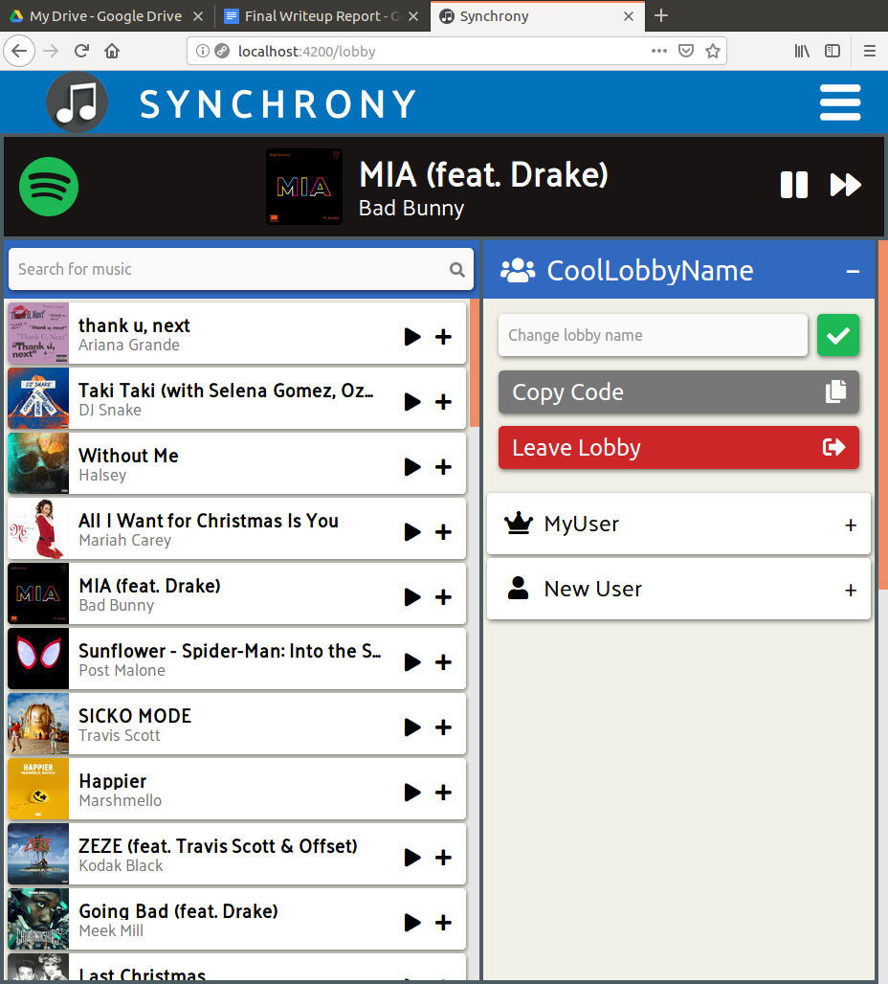 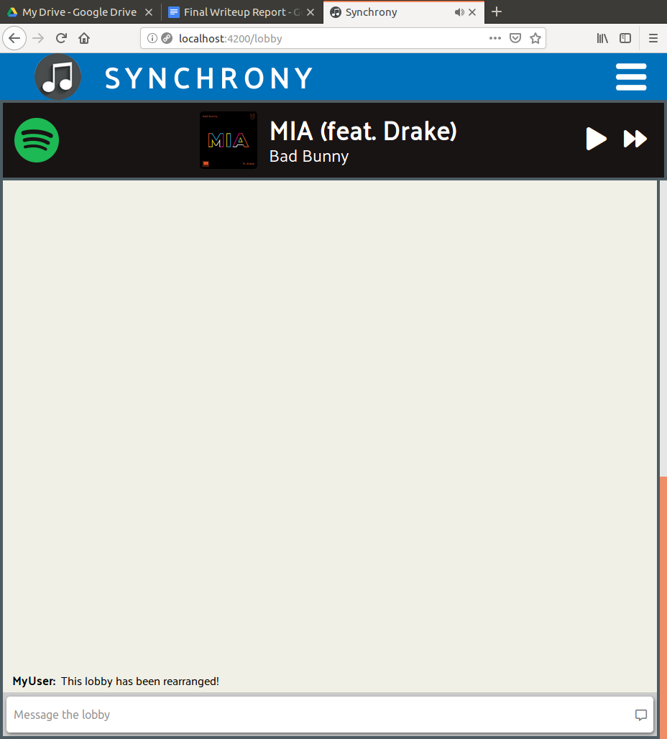

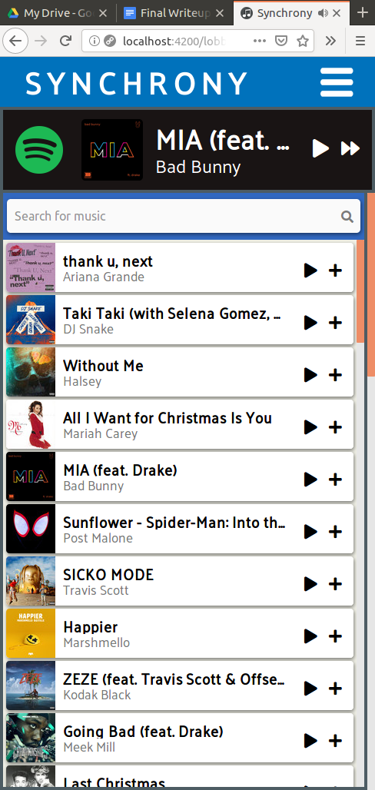 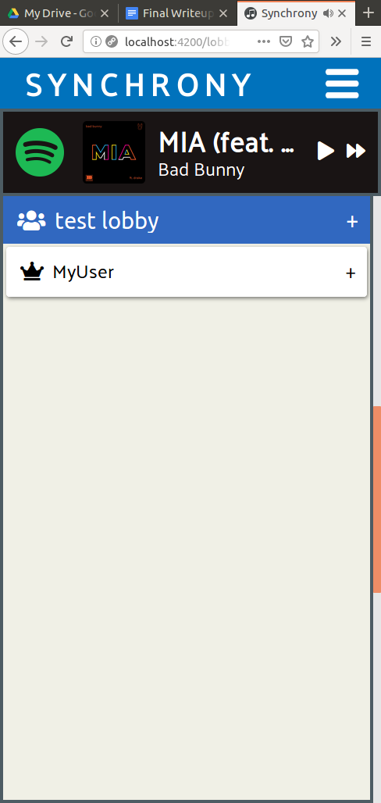 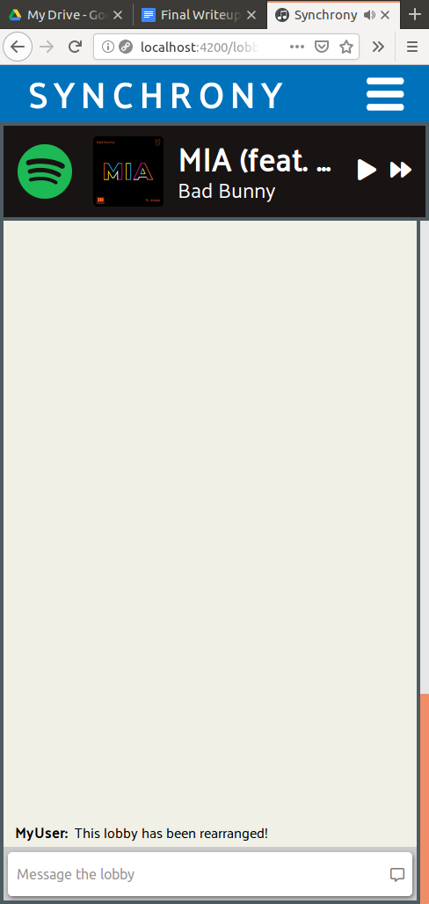

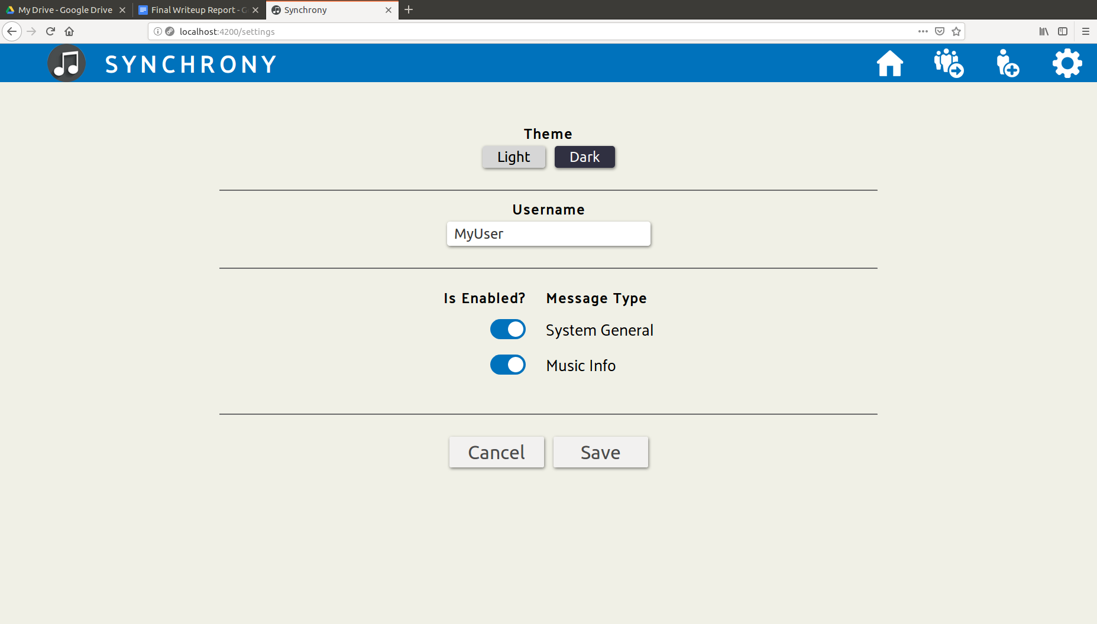

## **4. Languages / Tools**

### **4.1 Frameworks**

Synchrony uses python’s Django framework for the back-end, and Angular 6.1.7 (the latest version at the time when we started the project) for the front-end. We chose Django because most of us already know python or would be able to learn it quickly, and Django is designed to require less code and development time than other back-end options. We chose Angular for the front-end because we knew we needed a single page application framework but none of us had any experience in React.JS, and our research suggested that Angular would allow for more code reuse across different platforms and make it easier to add native mobile support later on in the development cycle with NativeScript, since we decided to shoot for native Android and iOS support as a stretch goal. As is standard for Angular development, we used TypeScript and RxJS in lieu of JavaScript and promises.

### **4.2 Tools and APIs**

For package management, we will use npm on the front-end and pip on the back-end. The client side of the project is managed with the angular-cli. A connection to the Django server, which should be always running, will be made during initialization.

While our app is designed to make it easy to use additional playback sources in the future, we currently only support Spotify. We use their Web Playback SDK to serve songs on the client side and their standard Web API, through a python library called spotipy, to retrieve song information, search results, and read playlists.

## **5. Architecture / Design**

### **5.1 Application Architecture**

The high level architecture for Synchrony follows the client-server model. The server handles API calls for searching for songs and keeps track of the current state of all lobbies and users. This includes the current playback information for each lobby and the list of songs that have been added to each lobby’s queue, as well as the list of users in each lobby.

Our app only uses HTTP requests to communicate with the server. Each lobby has a host, and that host sends an update to the server periodically with playback information, including which song is playing, if it is paused or not, and what the current position in the song is. All clients in the lobby periodically make requests to the server for the most recent playback information, and if any client is out of sync with the most recent playback status kept on the server, their playback is updated accordingly.

Any user in the lobby can control playback for the whole lobby, but because every user has a flag set that indicates if they are the host or not and each lobby can only have one host, we could easily add a toggle in the settings menu in the future that would allow the host to disable playback control for every user except for themselves, or even grant admin privileges to other users.

### **5.2 Client-Side Architecture**

The client side of Synchrony follows the model-view-* based architecture used by the Angular framework, where the model is a *class/interface*, the view is a *template*, and the controller/viewmodel/etc. is a *component*.

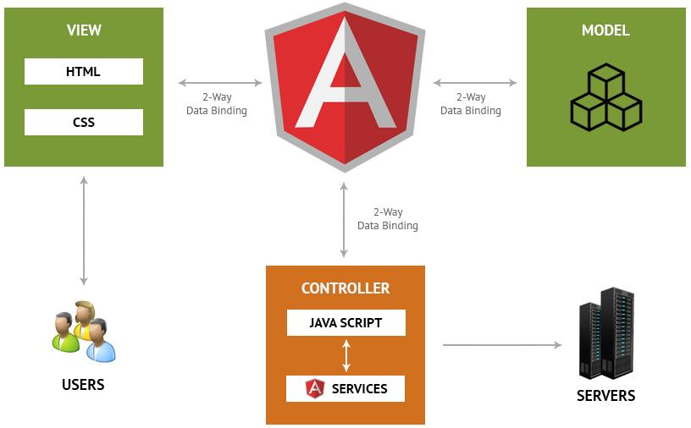

*Figure 5.2: Architecture for the Angular client*

### **5.3 Key Components**

Components are the basic building blocks of an Angular app. Each component defines:

* Any necessary imports needed by the component
* A component decorator, which includes properties that allow you to define the template, CSS styling, animations, etc..
* A class, which is where your component logic is stored.

Here are the components that come together to make the lobby page, which holds the app’s main functionality once the user has joined or created a lobby:

music-info.component

* Contains the playback component, which uses the music service to provide controls for the current song (play/pause and skipping tracks)
* Displays info on current song such as title, artist, and album cover

rtc.component

* Chat history and message bar for the user to enter text
* System generated messages for when people enter/leave lobbies and when users play/pause, skip, or queue songs.
  + These messages can be toggled on and off in settings

search.component

* Search bar for users to enter song queries, displays results below the search bar
* Allows users to play songs that show up in search results, or to add them to the queue
* Displays the current top 50 songs when there are no search results

lobby-info.component

* Show who is in the lobby and the lobby name or invite code

title-bar.component

* Display the name of the app, Synchrony, and buttons to open things like the settings menu

### **5.4 Database Design**

Our database will run on PostgreSQL which is an object-relational database. It will be connected to the django backend. It contains six tables: Lobby_Info, User_Info, Lobby_Members, Playback, Songs, and Messages. Primary keys are denoted in the following drawing with a *. Foreign keys are denoted with an arrow.

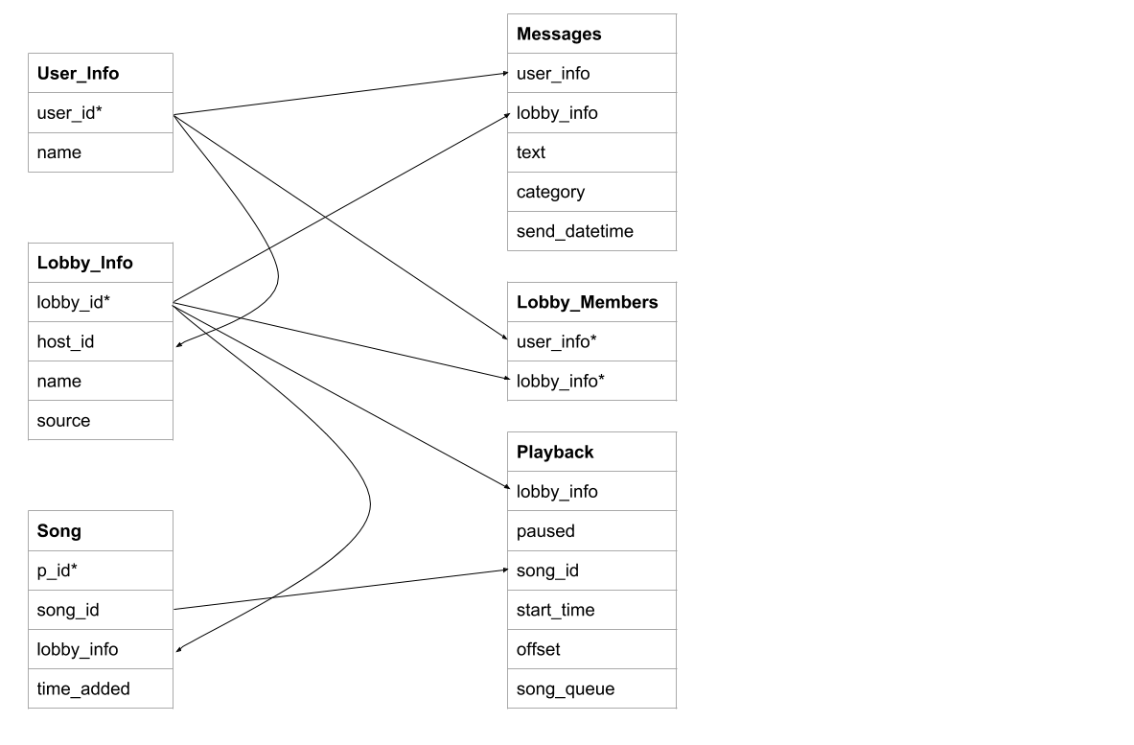

## **6. Testing / Documentation**

### **6.1 Testing**

Each method in the backend was tested using Django’s built in testing tools which are based on the unittest module in python 3. We generated coverage reports using coverage.py

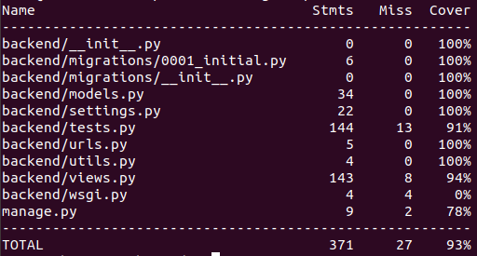

Figure 6.1 The Backend Test Coverage

Testing the frontend was done using the [Jasmine test framework](https://jasmine.github.io/) and the [Karma test runner](https://karma-runner.github.io/2.0/index.html). With these tools, we can run ng test in the command line to automatically execute all tests and view a summary of the results, and we can append the flag --code-coverage to see our coverage metrics. Using the Angular CLI for testing means that any time a change to the code is saved our tests will automatically start to run in the background. As a result, we avoid the need to set up any sort of test automation.

### **6.2 Test Cases**

Test cases for the backend are rather obvious. First we have a test class that covers the creation of basic entries for our data model. This includes creating a user, a lobby, their Lobby_Members connection, etc. We then included a unit test for each of the views that are reachable from our API. We simulate this with the Django client, this allows us to fake API calls and to check that everything went alright and by varying the content of the requests we were able to reach near full coverage. 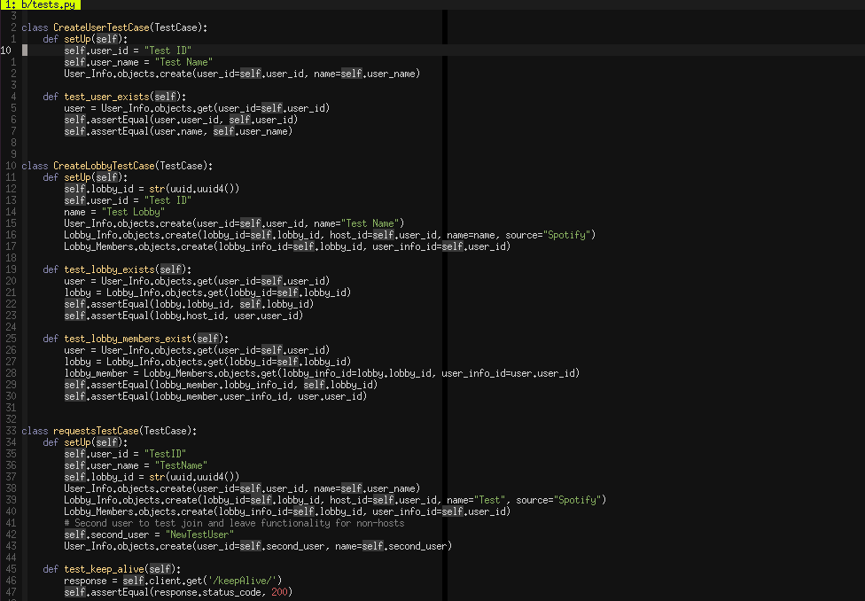

Figure 6.2 An example of backend test cases

### **6.3 Documentation**

For Django we generated documentation using django’s admin docs model. This allowed us to write all of our backend docs as docstrings, allowing for easy viewing during development as well as version control of our documentation.

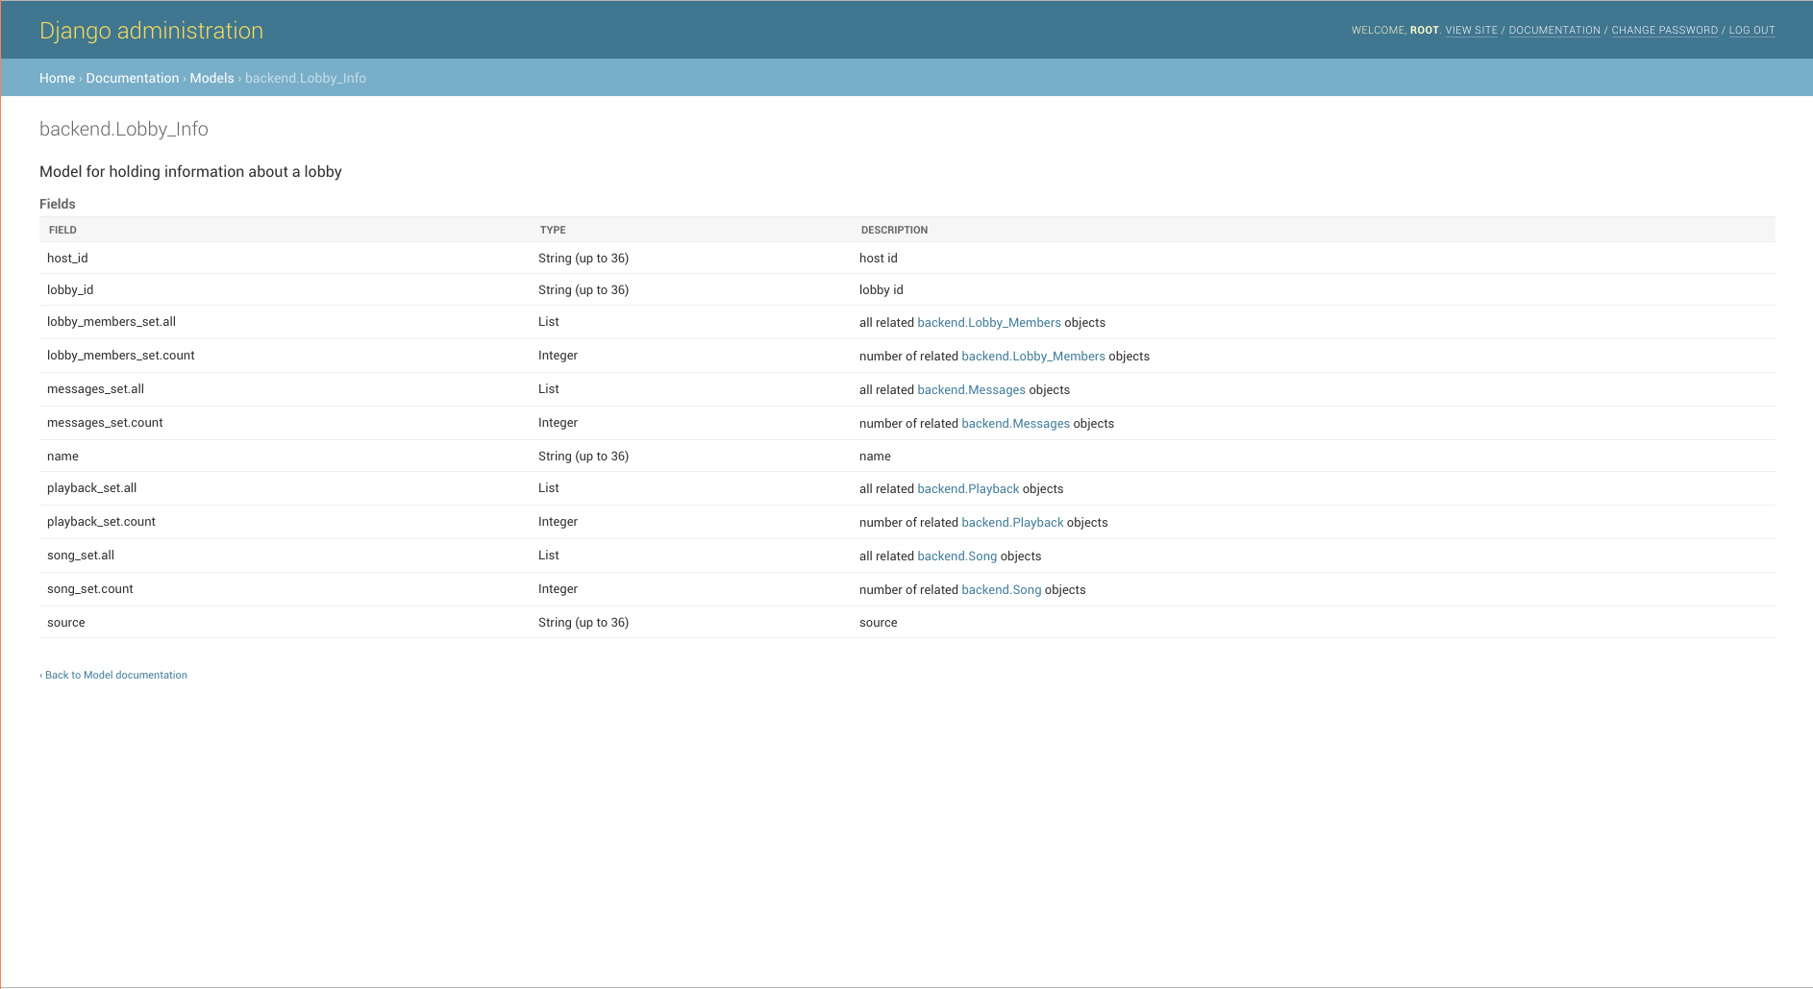

*Figure 6.3 : A screenshot from Synchrony’s Django admin docs*

To generate documentation for the frontend, we used [Compodoc](https://compodoc.app/guides/getting-started.html), because it allows us to write comments in the standard JSDoc style and then generate fancy Angular-specific documentation with a single terminal command and serve it as a web page.

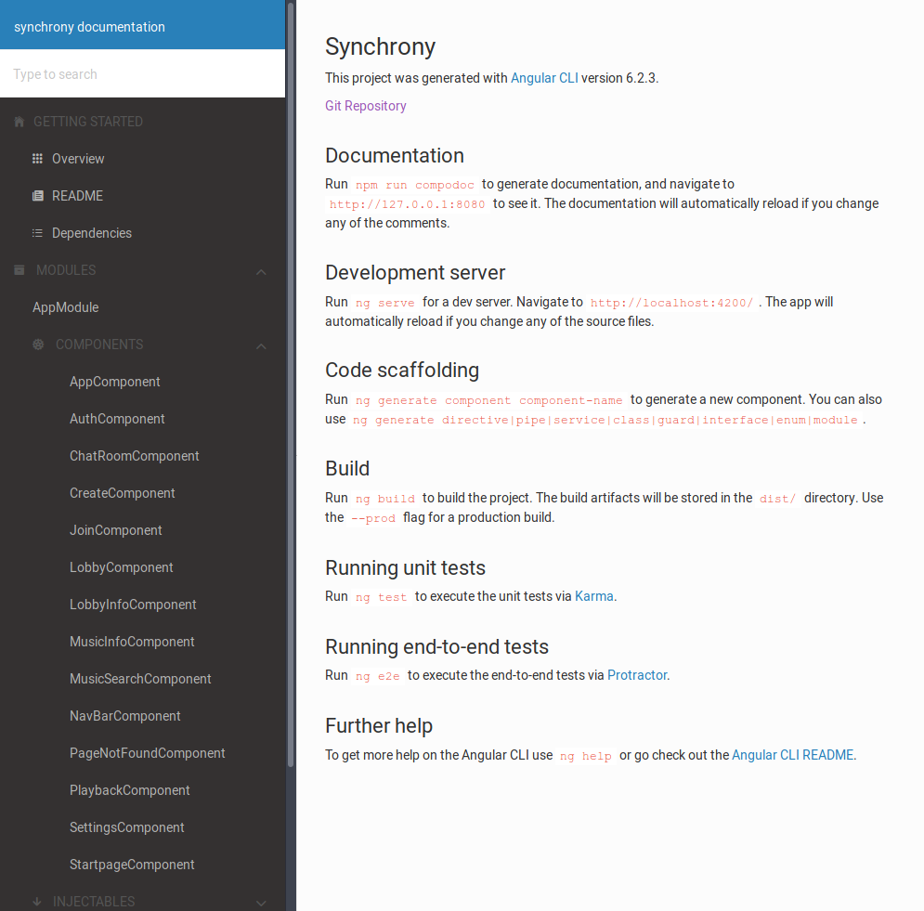

*Figure 6.4 : The Angular documentation generated by Compodoc*

## **7. Use Cases**

Synchrony provides conceptually basic features. Foremost is the syncing of music playback, and related other features like song queuing, chat functionality, skipping songs. This simplicity allows for a range of uses cases and great variations upon the broader use cases. We will discuss three major use cases.

The first use case is also our initial intended use case. Multiple users all access synchrony in a lobby, all with playback enabled, and can optionally chat in the chatroom. These users could be friends or family communicating over long distances and are using it as a means of connecting. Potentially the users could also be physically present together but lack high quality speakers or do not wish to disturb others around them by playing their music. Another but tangential example would be for makeshift silent discos.

The second makes use of only the song queuing and skipping features. Synchrony allows for song queuing and searching to still function without connecting to playback. This allows users hook one system up to a speaker, and simply use the lobby as a mobile jukebox.

The third would be to use Synchrony to roughly, and cheaply, sync various speakers in a house during a party or event. Proper sound systems can be quite costly and often require specific hardware and wiring, Synchrony avoids this at the potential cost of synch quality.

## **8. Project Status**

### **8.1 Accomplishments**

We were able to complete all of the core features we had listed in our initial proposal. Our first accomplishment is the implementation of listener lobbies. The lobbies provide a clean graphical user interface for people to view other users in their lobby and to view the music being played in the lobby. With this implementation, the ability to join other lobbies is a core feature to Synchrony, since without this feature there is no way to share music with others. Making lobbies joinable with their lobby ID was our first achievement for Synchrony.

Our next accomplishment was the implementation of the Spotify streaming service. The first part of this goal was to get audio playing in the listener lobbies through the Spotify API. We were able to achieve this by eventually sending a call to the Spotify API by using the URI of the requested audio track. Once we were able to accomplish this, the next part was synchronizing the audio for every listener in the lobby. We were able to achieve synchronization within a threshold of five seconds.

Our final main accomplishment was the implementation of real-time chat in listener lobbies. The chat does not only allow users to communicate through text, but it can also display other actions that occur in the lobby. With this option turned on, the chat can notify when a song is played or paused, and who played or paused the song.

### **8.2 Omissions**

Though we were able to accomplish all of our core features, we were not able to implement most of our stretch goal features. One omission is Native (mobile) support for Synchrony. One use case we had for Synchrony is potentially cross-platform system where someone can join a lobby from their smartphone while others may use their laptop or home PC. People would be even more likely to use Synchrony if they could easily join lobbies through their smartphone on the go. Though we don’t currently support mobile use, it is something we would like to implement in the future.

The next main feature we didn’t implement is the ability to vote on songs. As of now, any user in a lobby can play a song if they log in to their spotify premium account. In the case that only the host can play music, we wanted to add a feature where users can vote on what tracks get played next. This would allow users to have more input on their music preference and give them a voice to share what they like to hear. In return, the host would also be able to learn about others musical preference and would contribute to part of the shared listening experience.

The last feature we weren’t able to implement is the ability to switch between multiple audio sources. As of now, we only implemented Spotify as the audio streaming service. We initially began implementing SoundCloud as our next streaming service, but we were not able to finish due to SoundCloud no longer providing support for registering new applications. We had also planned on implementing other APIs such as YouTube, Apple Music, and Pandora, but we focused on delivering better synchronization for Spotify rather than implementing multiple audio sources. Though we were not able to add additional audio sources, it is something we would also like to implement in the future.

### **8.3 Lessons Learned**

One of the biggest lessons we learned over the course of this project was to use the most complete technology for the job. Using websockets rather than traditional requests would have significantly eased the syncing and messaging portions of the implementation since we could have the backend server simply let the front end know when it had updates rather than the frontend needing to poll the backend every three seconds.

Another major lesson we learned was to limit the amount of auto generated code which was committed to the repository. Django migrations are autogenerated by the Django server to represent changes to the database model which have occured. When the server is not kept running between updates of the model, these migrations are not useful. Furthermore, they have difficulties when used with git as they have nonstandard file permissions and ownership which present problems when they are pushed to a repository and then pulled by another user. Collectively this issue caused several hours of headaches across the team. We could have prevented this issue by including the migrations folder in the git ignore and generating them each time we spun up the server.

Finally we learned several lessons about communication in distributed teams. For this project we used the free tier of trello and slack for communication. These tools lead to some issues as they did not permit some of the features which would have made communication easier. The free tier of trello does not permit the linking of issues as dependencies. This meant that every time that we went to check to see if something was possible to do, we had to check the status of every card. This checking became more difficult if we did not update the status of the cards appropriately as we then had to go look at the code base. Furthermore, communication could have been furthered by more in person meetings. Throughout the course of the semester, we did not frequently meet in person. This lack on in person meetings lead to some lapses of communication where people did not know that others were depending on features they had yet to implement. These lapses could have been remedied through an increase in in person meetings and more active use of slack.

## **9. Conclusion**

Our team began this project with idealistic goals and a drive to make a product that each of us truly wanted. We wanted a product that we could continue to use or at the least work on after we had submitted our final capstone deliverables. In the end, we completed what we set out to accomplish. Our services synchronously plays back audio from one of the most popular streaming services, with over 40 million subscribers, in a completely legal way. We included chat to enable conversation, and song queuing and searching to let users browse and share. We didn’t end up completing our stretch goals, either due to time constraints, or in cases like soundcloud, where we simply lacked access. We also learned several lessons about poor technology choices, testing technologies, issues with data models, and team communication and systems. We’re proud of what we’ve made and hope we can carry this project forward into the future, or at the least inspire streaming services to offer Synchrony’s features themselves.

## **10. Individual Contributions**

### 10.1 Jacob Alspaw

Working with the Synchrony team was a fun experience throughout the semester. After nearly four months of work, our team was able to achieve something very special. As a team we were able to transform a simple idea into reality, and into a service that peers have expressed great interest in. As a developer on this team, I had many responsibilities that, other than the chat-room module, entirely pertained to front-end development of the Synchrony system.

The first component that I worked on was setting up an error page. Users would be redirected to this component any time an invalid URL was visited. It was my first time using Angular while building this component and it proved difficult to do so because I had no former experience with the technology. I am thankful that Owen was part of our team because his expertise and examples were enough to get my first module working. The module did not do anything special besides display text that told the user why they were seeing the current page alongside a neat graphic. Unfortunately, while still included in the source code, the module was later phased out of the app. Instead, the group chose to reroute the user to the home page when visiting an unregistered endpoint.

After making some of the basic pages, we saw an immediate need to start laying out the component views for the Synchrony service. I took responsibility with making the UI for most of the app. I started off by meticulously designing a layout that would feel flexible to Synchrony users. The layout users an complex use of CSS flexbox and javascript to resize. The website is extremely flexible for users with different size displays. Lobbies can be easily navigated even when viewed from very small screen sizes. The lobby layout is reactive to screen size and will shrink, grow, and even rearrange when necessary to accommodate the current viewing width and height. Depending on width of the screen, components will shift positions to give users the very best experience when using the Synchrony application. Even though I have plenty of experience with reactive designs for website layouts, making sure that each component would have sufficient room proved to be one of the most challenging parts of the semester.

I then took the next week developing the front-end portions of the join, create, chat-room, music-info, music-search, and lobby-info components. This included setting up buttons, laying out responsive text that would update according to model values, and making sure the components fit inside the confines of their size adjustable containers.

Around this time, our team decided that adding additional customizability for the web app would be greatly appreciated. I researched the best methods for doing so and came up with a solution to save user-specific settings quickly by storing cookies in the user’s browser. I was able to service that allowed each component in the app to retrieve these settings through dependency injection of the service into their own components. The settings page that I created acted as a wrapper to this service for use by the users. The settings page presents the user with a set of configuration options to modify their Synchrony experience. The options include, but are not limited to choosing a website theme, setting up their in-lobby name, and selecting filtering options for their chat logs. The theme options apply a different color scheme to the website. The chat log filters can reduce clutter in the chat room component of a lobby.

After setting up the basic components, I did further work on the chat room component and connected it to the backend. I made the necessary API endpoints to allow users to send their messages and update their chat logs. Django migrations proved very difficult through this part of the project, but Ted was able to help me through every problem I encountered. Even though the chat room module works as intended, I wish we took a different approach from the beginning. Using websockets would have been a much more efficient approach to creating a chat room feature as opposed to our current methods of repeatedly sending Ajax requests. Our initial thoughts were make it first and get it working. However, we should have approached the situation with the mindset of doing it right the first time.

After the chat room functionality was finished, I then began connecting other components to the chat room, allowing these components to send messages themselves. The purpose of this was to show the lobby members what actions other users were doing. This would include joining / leaving lobbies and playing / queueing music.

After this, Owen had finished setting up the playlist functionality which allowed me to add the currently playing song to the music info component. I set up a system that would retrieve metadata about the currently playing song and then display it in the user interface. I then set up the basics for the controls that allowed for playing, pausing, and skipping music tracks.

Nearing the end of the semester, I took the chance to revisit reevaluate the UI. The home page was looking very underwhelming and I knew it had potential to be so much more. I did all of the initial user interface design for the mockups and the current state of the user interface was subpar at best. I took a few days and began restylizing everything by myself. This gave Synchrony the finishing touches the system needed to be ready for the final presentation. In my opinion, the design ended up looking really good. Doing this part of the project really illuminated how nitpicky different browsers can be when evaluating CSS rules. Cross browser support with CSS is often hit or miss.

Redoing the user interface gave me great insight about the functionality of our app. After restylizing everything to fit a common theme, it was easy to see that our music search component was a little bit on the boring side. I decided that it would be a good idea to display something in the results section even when there was no text entered in the search input. I helped Alex fill this space when we developed a method that would query for the top fifty most popular songs worldwide. By doing this part of the project with Alex, I was able to teach him how to parse JSON objects using dictionaries.

It has been made clear to me throughout the semester that I was able to achieve my objectives through perseverance and time management skills. In this class and in industry, students and employees cannot afford to fall behind their planned work schedule. I learned that time management skills and interpersonal communication is the way to succeed in a team development environment that you would more often than not find in industry. The steps to a successful development process is interlaced with communication. By communicating, developers are able to reduce confusion and refine the objectives that they are working towards. Communication is surely one thing this team did correctly.

### 10.2 Owen Helmstetter

I ended up doing, and learning, a lot of different things throughout this project. Initially, I focused on setting up the Angular environment and helping the rest of team learn everything they needed to know for Angular development. Then as we started to work on the basic visual structure of the app’s components, I ended up focusing on the lobby-info component on the left side, where I wrote the CSS for an accordion style widget that would be used to toggle the display of detailed information and controls for the lobby such as an input to change the name, a button to leave the lobby, and an accordion for each user with whatever user-specific controls and information we would eventually need to add.

After that I worked on setting up our angular services, such as the lobby service to control the status of lobbies, actions to add and remove users from them, etc. and connecting them to our backend. This usually involved changes to both the front end and the backend, and I ended up creating a lot of methods on the Angular side that made http requests, and a lot of views on the Django side that accepted those requests.

I spent most of the semester writing the code for each of the services we needed, from joining lobbies with the lobby service to playing music with the music service. Most of the issues I ran into, once I figured out the ins and outs of developing with an Angular+Django+Docker stack, were with the Spotify APIs that our project depends on. We used both their Web API and their Web Playback SDK. I had a lot of trouble authenticating the Web API on our backend, but I eventually discovered a python library called ‘spotipy’, which made things much easier. We ended up using this API for getting info on songs given their URI, performing searches, and reading playlists.

For playing music, I had to rely on the Web Playback SDK which required that I set up user authentication on the client. This probably ended up being the most challenging part of the project for me. The playback api was written in a way that made it extremely hard to adapt to an Angular environment. Even importing the api into the project required a custom method to inject the API’s javascript file and trick the Player object we needed into thinking it was finished initializing in order to use it. Then after trying many different approaches to get authentication for this api working and continuing to fail, I ended up having to make a pull request to an obscure node package that handles Spotify authentication in Angular to get it working with our newer version. My patience was definitely tested throughout the process, but after all that work authentication now works flawlessly.

The last major part of our project that I worked on was playback syncing. I ended up adding the playback models and views on the backend and writing the music service for the frontend, as well as determining the logic for the playback component to parse updates to the playback status. The big challenge there was the asynchronous nature of Spotify’s playback SDK, and the fact that there was no way of knowing when an action is finished until the “player state” that Spotify sends to an action listener changes. This meant that I had to manage state in three places at once: the lobby host’s spotify player, the music service, and the server.

The end result of all this is that I learned a lot about authentication and setting up apps with client-to-client interaction where clients can’t communicate with each other directly. If I could have changed one thing about our approach, it would be to set up websockets from the start instead of putting it off until it’s too late. While our app in its current state works really well for a few lobbies with a few users, the server would never be able to handle even a few hundred users each updating their state every few seconds.

### 10.3 Alex Hemm

While working on this project, I used a lot of languages/frameworks that I was not as familiar with and had a small amount of experience. As a result I was able to learn a lot about web development and build off of what I already knew. Initially, I was assigned to work on more of the frontend components of our project. I came into the project with knowing HTML5 and CSS, and with some knowledge of developing MVC applications. But despite my previous knowledge of MVC architecture, we ended up using a different architecture and I was able to receive help from the rest of the team when I had questions.

Most of my work for this project was learning and using the Spotify API to pull data to audio tracks to display on the frontend of our application. After looking through the API, I saw that requests made to the Spotify were returned as JSON files. The JSON contained all sorts of metadata on the requested object. For example, you could make a request based off the URI of a spotify track, and the API would return the album art, artist, date created, and additional information about the audio track.

The trick was finding a way to parse the JSON file to assign these values to pre-created fields in our application. In order to do this, I had to extract the appropriate fields from the JSON file returned by the API into a JSON format that our application would use to get the values for those fields. Once I was able to do this, the song metadata was able to be displayed on the frontend for whichever song the user currently selected to play.

This technique also applied to displaying search results for our application. Fortunately, the Spotify API already had pre-defined request for song searching. The request would change based off the input text, so I was able to pass the input text field into the API and have it return a list of audio tracks. For each audio track, I also had the track metadata parsed so that the frontend could display the metadata for each search result. I also made some customizations to the search results such that the Spotify API would display the first twenty results from the input text instead of the default ten tracks.

The last part of the Spotify API was pulling data from playlists. This was little different since the Spotify API would return a playlist object rather than a list of tracks. In order to deal with this, I was able to use a method similar to the searching method that would enumerate each track in the playlist and pull metadata separately for each audio track. For the purpose of our application, we pulled this data from the global top fifty playlist on Spotify so that the search results would display these tracks when the user does not type anything in the search bar.

Besides working with the Spotify API, I helped with other various things such as setting up testing for Python at the beginning of the project. After doing that, I had written a module for our playback component to help organize what information we may need from audio tracks and to layout how we the playback controls would work. In addition to this, I also wrote a component for SoundCloud as a possible streaming service for our application. I set up the component such that the streaming would play certain tracks based off the genre the user selected. Unfortunately, I was not able to test this out since SoundCloud does not currently support registering new applications to use the API. A client ID token is needed to test out the API, so we could not add this to our project. I left the module there in the case that SoundCloud does decide to support the API in the future.

The last thing I worked on for this project was Angular unit testing for the frontend of our application. The unit test cases themselves weren’t that difficult, since it was just testing names of lobby fields components and button click functionality. However, the tests did involve some mocking to test the appropriate methods and to get the tests to work properly. I was able to achieve mocking by either creating mock classes that extended our actual classes or using Spy components that were implemented by Jasmine.

Overall, I learned a lot from this project and was very satisfied with our end product. I had speculations about everything working correctly since we were using so many different frameworks, but everything ended up working out smoothly in the end. I was very fortunate to have a helpful and dedicated team to work with on this project. I look forward to building off what I learned from this project and hopefully adding more useful features to Synchrony.

### 10.4 Ted Timbrell

During this project I ended up wearing different hats than I was expecting and running into more issues than I could have guessed. The rest of the team was great at helping out with different issues and filling roles that just needed to be filled. As a result I did the same.

When work on the project first began I mainly responsible for working on the back-end. Meaning that I helped Bobby set up what we needed for the data model, worked on the logic for what we estimated we’d need to sync playback on the client side, and writing the initial views that we’d knew at the minimum we’d need for our project to function. We did this by examining the functions we’d be given by the Spotify Web Playback API, and creating basic users and lobby models. This ended up being changed significantly once Owen got down to brass tax with the API itself and the many issues that an API in beta has.

This was my first time working with Django, despite having worked in Python for quite a while. While Django makes things quite easy, it’s not without issues. Primarily issues surrounding internal server errors, data models not being migrated correctly, and networking issues. Curiously Angular’s console output tends to just say that internal server errors are actually Cross Origin errors, which makes things incredibly complicated to debug as you always need to double check the request and header raw text. We also were getting actual Cross Origin errors, which didn’t help things. Django isn’t really meant to function alone without a load balancer facing outward, which looking back we should have included for full deployment. We could then have mapped our service all on a singular port to prevent these issues. During our development of this project I tried to function as a problem solver for any issues others encountered with the backend.

Midway through the project I switched over to working on getting users assigned on load and getting the members to function correctly. We had initially only had user ids being assigned when joining or enter a lobby, however we wanted a single user to be able to join multiple lobbies, and have users be consistent despite lobby state. I set the user creation up so that it initializes on load instead. This has issues however, mainly that if database is not functional yet, or if data is lost, the client is left thinking its user id is great, despite it no longer existing. Future versions could mitigate this. The saving of individual user data is also nice because usernames are saved across lobbies and it drastically simplifies our cookie service. Secondly I set up the lobby members functionality. While others had written pieces and UI for the placement, the method and API calls hadn’t be properly implemented on the client side. This was my first forte into Angular so it was frustrating but rewarding to figure out how get requests and promises fully worked.

Beyond the technology issues discussed above, I also had my laptop die midway through the semester. This basically crippled my ability to work on the backend of the project, as my only computer option was a old desktop with an operating system that was incompatible with Docker. I ended up writing some basic code to try to get the Spotify web API to serve our backend, and registered our app. However, I couldn’t actually run this code, or push it uncommented without potentially harming the development process of my team members. My team ended up using the spotipy library instead due to simplicity and issues with a direct connection. Due to these circumstances I ended up taking a hole plugger role during this period, filling in the gaps in functionality for lobby members like I discussed above, solving model errors due to migrations, in particular the songs model, and debugging issues with team members.

After this, when we were nearing the end of the project I spearheaded the push to get backend testing done. I ended up writing most of the testing for user, lobby, and playback functionality. I made it my mission to get 100% coverage of our views. On some commits on the 10th week were quite close, however we pushed a couple last minute changes which ended up improving the quality of our service but decreasing our great testing statistics. The testing module for Django is fantastic and despite having to enter the docker container each time I had to test, it was quite a painless process.

I also attempted to get our server running on AWS. For the same issues that I talked about with Django this ended up being quite obnoxious and ran into one too many CORS errors and issues with serving angular properly, as Django’s static file serving ended up being quite obnoxious to work with. In the future I dedicated web server host, or compatible load balancer should be used to serve up our content.

Probably my biggest fault or biggest insight I had is just how much a good project management software matters. I found the free version of Trello we were using to be completely inadequate and incredibly hard to navigate. This led to a lot of our communication being done over Slack, and in one or two occasions I accidentally tripped over my teammates toes and duplicated functionality. Thankfully this was quite limited.

In conclusion I’m quite happy with the product we’ve created. If I remember correctly I was the one to pitch this idea, and it’s better than I really could have imagined. I learned a lot about working on a bigger size team, and about new technologies that I otherwise wouldn’t have touched.

### 10.5 Bobby Wagner

My primary role for this project was to work on the backend and to set up tooling to ease the development process for my group members. Throughout the first weeks of the project, along with Ted, I set up the majority of the models for the database as well as set up the docker compose files in order to spin up both the Django server and the accompanying Postgresql database. Additionally, during this time I set up initial tooling to automate code style using pre-commit. Overall, these steps went swimmingly and with the exception of a few tweaks provided a good initial foundation for backend development.

Following the initial setup of the models and infrastructure, I began working on exposing as much of that functionality to be able to be used by the frontend as possible. At this time it was not clear that we would be hosting the frontend as a seperate server and as such I spend my time creating views which did simple things with the model such as adding a user in order to make them more extensible later.

Around the time the initial views were created, several issues popped up that I dealt with. Firstly, docker does not rebuild images unless you manually tell it to, regardless of if its dependencies have changed. This is especially interesting when used with Django as the changes to the python files are adequately reflected but changes to requirements are not. This means that if someone else changed a requirement, then the entire server does not run potentially without rebuilding. It took me several days to diagnose the actual cause of this issue as all of the error messages indicated the requirement was not installed which made me think it was more of an issue with my path than the docker build. Following the diagnosis of this issue, I added the fix to the automation of the project so that it was not an issue again.

Another major issue that plagued me around this time was issues surrounding migrations. Migrations created in Django using docker do not play well with git as they are created by the root user and thus when pulled after pushing cause a permissions error with creating the file. If you are pulling in many changes this also has the side effect of heavily polluting the working directory with unstaged changes due to errors in how git works with pulls. Several days of my time were spent diagnosing this issue which I then was able to help my other group members with at later times.

One non technical stumbling block that I had was that I went into this project with little knowledge of front end architecture. This lack of knowledge made it difficult to parse the code on the front end because angular adds many files which are irrelevant to the function of the code in respect to the backend. As a result of this difficulty in parsing, I sometimes had difficulty figuring out what needed to be done on the backend to support the functionality they were expecting. This difficulty in parsing needs was at some points exacerbated by poor communication and poor use of project management software.

One way that I attempted to ease the communication was to invest heavily in development of documentation. Each model and view was documented as to their function and structure in docstrings right next to the method. In addition, these docstrings were compiled to a useable webpage which could be accessed any time the backend was running.

I also worked with Ted to ensure that the project had good test coverage. This involved writing a multitude of tests in sometimes creative ways in order to make sure that we hit each possible branch of every view. Often times this meant passing very weird queries to the view in order to induce database failures as we were unable to mock these. Overall, Django’s test helpers made the testing processes quite easy. One way we could have made testing better would have been with better encapsulation so that the views only had to parse the request and then we could more rigorously test the logic elsewhere. This encapsulation most likely would have lead to more sound tests.

Overall, throughout this project I took more of a support role, focusing much of my time on infrastructure and tooling to make the development process easier for my teammates. I also contributed many of the backend views and api’s which made it possible to easily get data from the database to the frontend without complicated queries. I learned many things about working in distributed teams on this project as often times they are much more difficult to deal with unless you set up formal communication patterns beforehand like you would have in an office setting. I will definitely keep these insights in mind if I end up working in a distributed setting.

I am very happy with the product that we made as I feel it solves the need that we set out to solve. I plan on using this product in my daily life to synchronize music across my apartment.